Square Cupola
# Source: AI Source: Provided by: [Data Path: Persons Table -> ID Column: 1, Name_En Column: Motasem Essam] -> From: [ChatGPT] on [7/25/2026]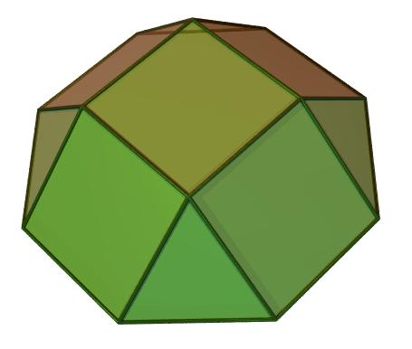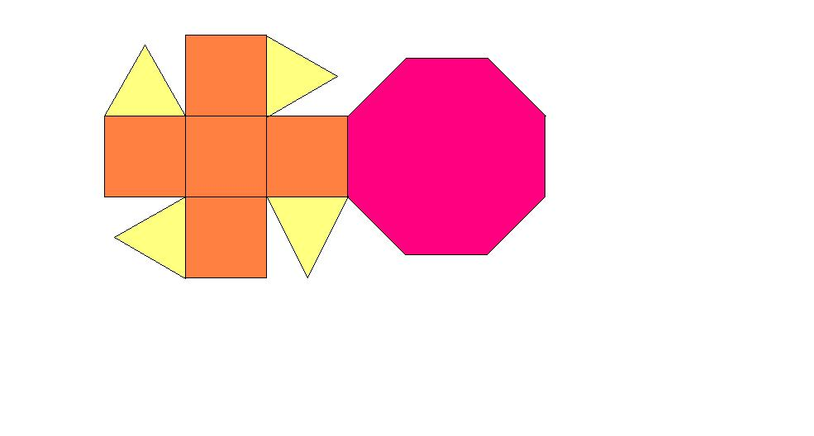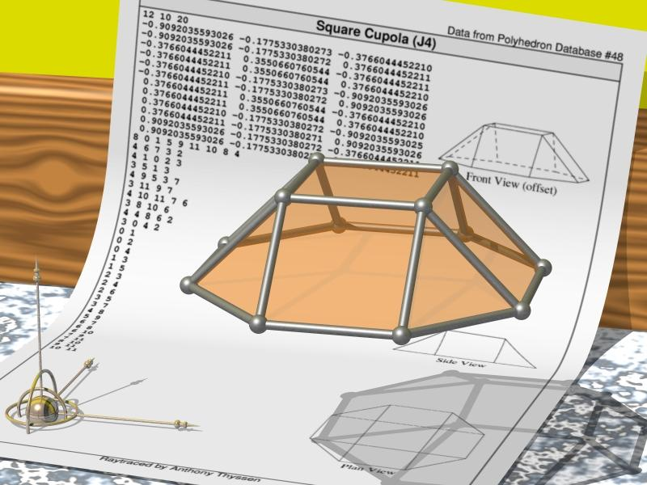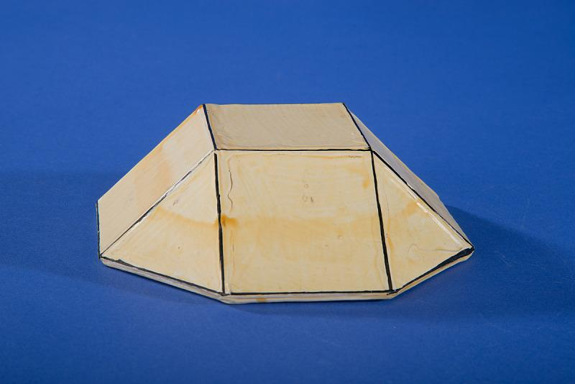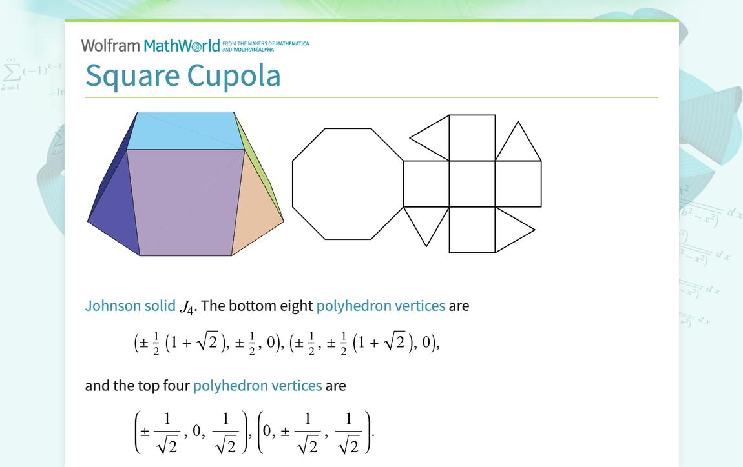

Definition
# Source: AI Source: Provided by: [Data Path: Persons Table -> ID Column: 1, Name_En Column: Motasem Essam] -> From: [ChatGPT] on [7/25/2026]
A Square Cupola is a convex polyhedron consisting of:
- One square upper base.
- One regular octagonal lower base.
- Four equilateral triangular lateral faces.
- Four square lateral faces.
The two bases are parallel, and the triangular and square faces alternate around the sides of the cupola.
The square cupola is one of the Johnson solids, specifically Johnson solid J4.

Geometric Structure
# Source: AI Source: Provided by: [Data Path: Persons Table -> ID Column: 1, Name_En Column: Motasem Essam] -> From: [ChatGPT] on [7/25/2026]
- Upper Base: A square.
- Lower Base: A regular octagon.
- Lateral Faces: Eight faces arranged alternately:
- 4 equilateral triangles.
- 4 squares.
- Arrangement: The square base is positioned above the octagonal base, with alternating triangular and square faces connecting their edges.

Face Composition
# Source: AI Source: Provided by: [Data Path: Persons Table -> ID Column: 1, Name_En Column: Motasem Essam] -> From: [ChatGPT] on [7/25/2026]
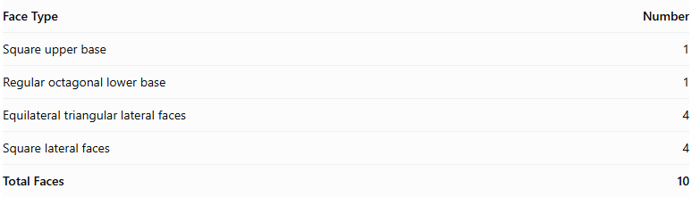
Face Type | Number
Square upper base | 1
Regular octagonal lower base | 1
Equilateral triangular lateral faces | 4
Square lateral faces | 4
Total Faces | 10

Mathematical Properties
# Source: AI Source: Provided by: [Data Path: Persons Table -> ID Column: 1, Name_En Column: Motasem Essam] -> From: [ChatGPT] on [7/25/2026]
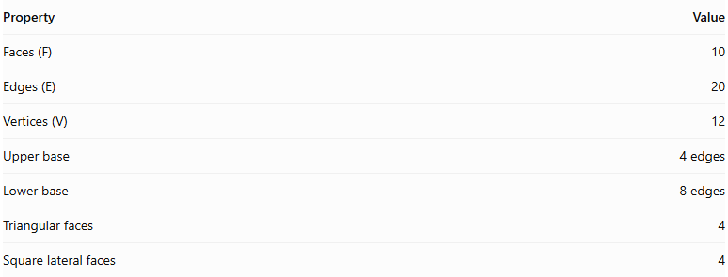
Property | Value
Faces (F) | 10
Edges (E) | 20
Vertices (V) | 12
Upper base | 4 edges
Lower base | 8 edges
Triangular faces | 4
Square lateral faces | 4
Euler's Formula:
$$V-E+F=2$$
$$12-20+10=2$$
<badge color="success">Euler's formula verified</badge>

Geometric Characteristics
# Source: AI Source: Provided by: [Data Path: Persons Table -> ID Column: 1, Name_En Column: Motasem Essam] -> From: [ChatGPT] on [7/25/2026]
- The square and octagonal bases are parallel.
- The square upper base has 4 vertices.
- The octagonal lower base has 8 vertices.
- Each lateral face connects edges of the two bases.
- The lateral faces alternate between triangles and squares.
- The solid has rotational symmetry of order 4.

Constructing Square Cupola in Solid Geometry

Geometric Instruments Used
# Source: AI Source: Provided by: [Data Path: Persons Table -> ID Column: 1, Name_En Column: Motasem Essam] -> From: [ChatGPT] on [7/25/2026]
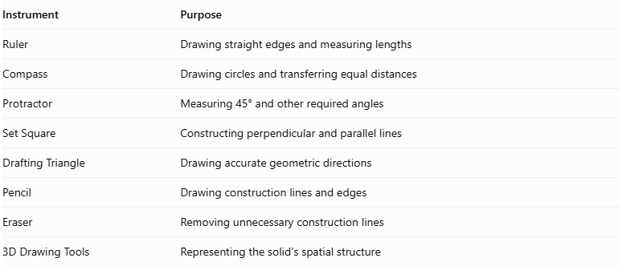
Instrument | Purpose
Ruler | Drawing straight edges and measuring lengths
Compass | Drawing circles and transferring equal distances
Protractor | Measuring 45° and other required angles
Set Square | Constructing perpendicular and parallel lines
Drafting Triangle | Drawing accurate geometric directions
Pencil | Drawing construction lines and edges
Eraser | Removing unnecessary construction lines
3D Drawing Tools | Representing the solid's spatial structure

Instrument-Based Construction Procedures
# Source: AI Source: Provided by: [Data Path: Persons Table -> ID Column: 1, Name_En Column: Motasem Essam] -> From: [ChatGPT] on [7/25/2026]
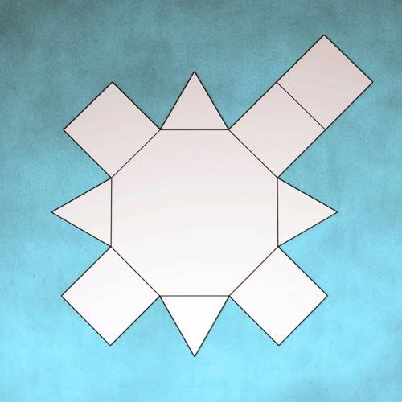

Constructing the Octagonal Base
# Source: AI Source: Provided by: [Data Path: Persons Table -> ID Column: 1, Name_En Column: Motasem Essam] -> From: [ChatGPT] on [7/25/2026]
- Draw a circle using a compass.
- Divide the circle into eight equal angular sections using a protractor, with a central angle of ${45}^{°}$.
- Mark the eight points on the circumference.
- Connect consecutive points using a ruler.
- Complete the regular octagonal base.

Constructing the Square Upper Base
# Source: AI Source: Provided by: [Data Path: Persons Table -> ID Column: 1, Name_En Column: Motasem Essam] -> From: [ChatGPT] on [7/25/2026]
- Draw a square using a ruler and set square.
- Make each side equal to the required common edge length.
- Position the square parallel to the octagonal base.
- Align the square with the octagon so that its four vertices correspond to the appropriate alternating positions around the lower base.
- Establish the required perpendicular separation between the two base planes.

Constructing the Lateral Faces
# Source: AI Source: Provided by: [Data Path: Persons Table -> ID Column: 1, Name_En Column: Motasem Essam] -> From: [ChatGPT] on [7/25/2026]
- Identify the four alternating groups of vertices around the octagonal base.
- Connect the appropriate octagonal vertices to the four vertices of the upper square.
- Construct four square lateral faces between the corresponding base edges.
- Construct four equilateral triangular lateral faces between the square faces.
- Check that the triangular and square faces alternate around the solid.
- Ensure that all shared edges have matching lengths.

Finalizing the Solid
# Source: AI Source: Provided by: [Data Path: Persons Table -> ID Column: 1, Name_En Column: Motasem Essam] -> From: [ChatGPT] on [7/25/2026]
- Draw the visible edges using continuous lines.
- Represent hidden edges using dashed lines where necessary.
- Check the arrangement of all ten faces.
- Verify that the square upper base and octagonal lower base are parallel.
- Erase unnecessary construction lines.
- Complete the three-dimensional representation.
Construction note: This is an instrument-based geometric construction using rulers, compasses, protractors, and geometric relationships. It is not coordinate-based construction.

Key Points
# Source: AI Source: Provided by: [Data Path: Persons Table -> ID Column: 1, Name_En Column: Motasem Essam] -> From: [ChatGPT] on [7/25/2026]
- A Square Cupola is a type of cupola with a square upper base and an octagonal lower base.
- It contains 4 triangular and 4 square lateral faces.
- It has 10 faces, 20 edges, and 12 vertices.
- It is classified as a Johnson solid (J4).

Classification
# Source: AI Source: Provided by: [Data Path: Persons Table -> ID Column: 1, Name_En Column: Motasem Essam] -> From: [ChatGPT] on [7/25/2026]
Solid Geometry
└── Types of Solids
└── Cupola
└── Types of Cupolas
└── Square Cupola

Conclusion
# Source: AI Source: Provided by: [Data Path: Persons Table -> ID Column: 1, Name_En Column: Motasem Essam] -> From: [ChatGPT] on [7/25/2026]
The Square Cupola is a convex polyhedron formed by joining a square and a regular octagon with four alternating equilateral triangular faces and four square faces. Its structure gives it 10 faces, 20 edges, and 12 vertices.

